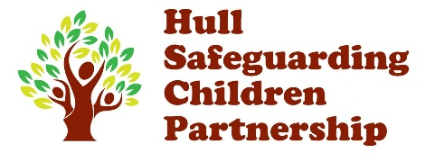
Neglect Observational Toolkit -

Name of child/young person: |  |  |  |  |  |  | DOB child/young person: | 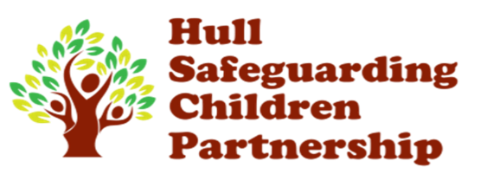  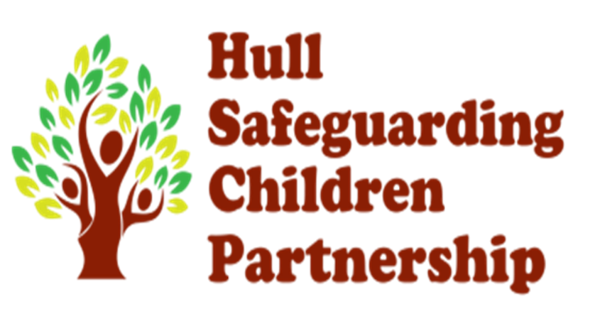
Address: |  |  |  |  |  |  | Details of parents/care givers:
Date tool kit completed: |  |  |  |  |  |  | Who has this tool kit been completed with? –
Was the visit announced? | Yes | ☐ | No | ☐ | Date of visits:
Name of practitioner undertaking assessment: |  |  |  |  |  | Job title: |  | Agency:

Scaling is used to make a judgement about the impact of a situation on a child/ young person. The scale goes from 0-10 and is part of the Signs of Safety model.
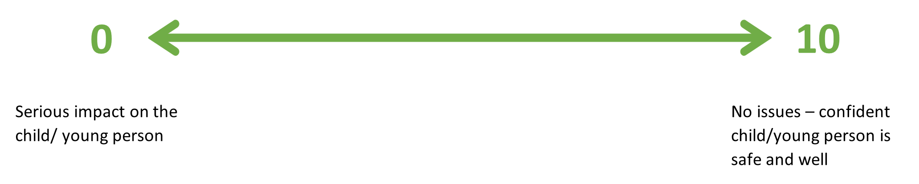
On a scale of 0-10, where 10 means the child or young person is safe enough and zero means things are really bad for the child or young person and they must be removed from the situation immediately, where do you rate this situation today?
When scaling, it is helpful to define what 0 and 10 mean, and always present 10 (what we are working towards) first.

Observations of the internal and external home environment
 |  | Safety Scale (0-10)  (See note above) | Details of observations. What would need to happen to improve the safety scale score?
1.1 | Home has adequate furnishings appropriate to individual child’s needs, including seating and floor coverings.
1.2 | There is room in the home environment for the child to live and play without items posing a safety risk. Rubbish is disposed of safely.
1.3 | Home in a state of good repair –  - No electrical hazards  - No structural damage which could pose a risk  - No evidence of damp/mold
1.4 | Home has basic amenities for washing and bathing. This includes a useable bathroom which is hygienic.
1.5 | Home has kitchen appliances to enable food to be prepared. The kitchen area is clean, and food is stored safely.
1.6 | Home has adequate heating and running hot water. Has gas heating been serviced?
1.7 | Outside environment is safe for a child to play and free of hazards which may cause injury.
1.8 | Home is free from pet/animal hazards including excrement and vermin. Animal excrement outside is cleared up promptly.
Observations of the internal and external home environment: Any additional information/ details –

Health and Safety
 |  | Safety Scale (0-10) | Details of observations. What would need to happen to improve the safety scale score?
2.1 | No evidence of exposed needles/ drug equipment/ medicines/alcohol in sight or reach of children.
2.2 | Evidence of animals in the home being well cared for and not subjected to any abuse or ill treatment.
2.3 | Evidence that the child is supervised around animals, if required.
2.4 | Dog is not considered dangerous and there is not a history of dog bites.
2.5 | Smoke alarms and carbon monoxide alarms present and in working order.
2.6 | No looped blind cords hanging freely. Where blinds are fitted in the household, they are cord / chain free or concealed.
2.7 | Emergency exits are accessible and not blocked. What would the families plan be in the event of an emergency?
Health and Safety: Any additional information/ details –

Sleeping Arrangements
 |  | Safety Scale (0-10) | Details of observations. What would need to happen to improve the safety scale score?
3.1 | The child/ young person has their own bed / cot.
3.2 | Furnishings are clean and in a good state of repair.
3.3 | There is a mattress and bed linen on the bed of the child/ young person. These are clean and dry.
3.4 | No evidence of locks/bolts on outside of bedroom doors.
3.5 | Child/ young person has age-appropriate personal space i.e., bedroom
Sleeping Arrangements: Any additional information/ details –

Care of babies/young children
 |  | Safety Scale (0-10) | Details of observations. What would need to happen to improve the safety scale score?
4.1 | Evidence of sterilizing equipment/baby milk/nappies.
4.2 | Evidence of age-appropriate toys which are available to the child.
4.3 | Evidence of babies/ young children being offered space and freedom to play.
4.4 | Evidence of age-appropriate supervision (also consider age-appropriate babysitters).
4.5 | Evidence of age-appropriate safety equipment i.e., stair gates and fire guard.
Care of babies/young children: Any additional information/ details –

Child presentation/health
 |  | Safety Scale (0-10) | Details of observations. What would need to happen to improve the safety scale score?
5.1 | Child displays happy/sociable/ active behaviour appropriate to age.
5.2 | Child seen to have clean skin/nails/hair/ clothes.
5.3 | No evidence of head lice/other infestation.
5.4 | The child has access to a toothbrush and visits a dentist regularly. Child has no dental pain / toothache.
5.5 | Physical health needs receive an appropriate and timely response from parent/carer i.e., routine and emergency health care.
5.6 | No evidence child is underweight/ overweight which may cause health related problems.
5.7 | Child is appropriately dressed for weather in well-fitting clothes
5.8 | Child exhibits social behaviour appropriate to age.
5.9 | Child is regularly fed and provided with adequate nutrition.
5.10 | Any additional needs of the child are understood and responded to including mobility needs and neuro diversity needs (i.e., autism, ADHD, epilepsy)
Child appearance/demeanor/health: Any additional information/ details –

Parental responses / interactions
 |  | Safety Scale (0-10) | Details of observations. What would need to happen to improve the safety scale score?
6.1 | Parents/ carers are responsive to child – i.e., child is comforted when distressed, requests for help are responded to.
6.2 | Affection is shown towards the child which are consistent with culture and values.
6.3 | Child is rewarded and praised for achievements.
6.4 | Child is guided towards appropriate ways of behaving.
6.5 | Parents have realistic  expectations of the child in accordance with their age.
6.6. | Child is adequately supervised in accordance with age (including parents/ carers knowledge of where teenagers are).
6.7 | Have reasonable steps been taken to protect the child/ young person from online exploitation?
6.8 | Does the child attend a relevant education provision? Does the parent/carer actively encourage attendance?
Parental responses: Any additional information/ details –

Adult causal factors (i.e., additional factors which may impact on child and contribute towards neglect)
 |  | Safety Scale (0-10) | Details of observations. What would need to happen to improve the safety scale score?
7.1 | Is there any evidence within the household of substance misuse or alcohol use which may impact negatively on the child/ young person?
7.2 | Does any parental mental health impact on the care provided to the child/ young person?
7.3 | Have you identified any dynamics of domestic abuse within the family relationship? Has the victim been seen alone to offer any appropriate advice and support? https://www.hullscp.co.uk/
7.4 | Do parents/ carers have a support network? Is there evidence of social isolation?
7.5 | Do parents / carers have any financial difficulties (e.g debts /poverty)?
Adult interactions/ relationships/ lifestyle: Any additional information/ details –
Are there any previous known concerns around neglect?
Overall summary of findings, including impact on child/young person?
What are the views of the care givers, child or young person?
What is working well? What needs to happen next to make any necessary improvements?

